1-What is Agile
Lecture 1- Intro to Agile, Scrum _ How to write_read User Story - start at 0:52
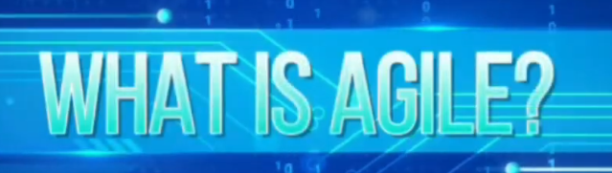
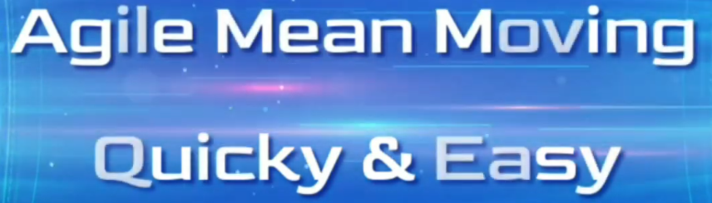
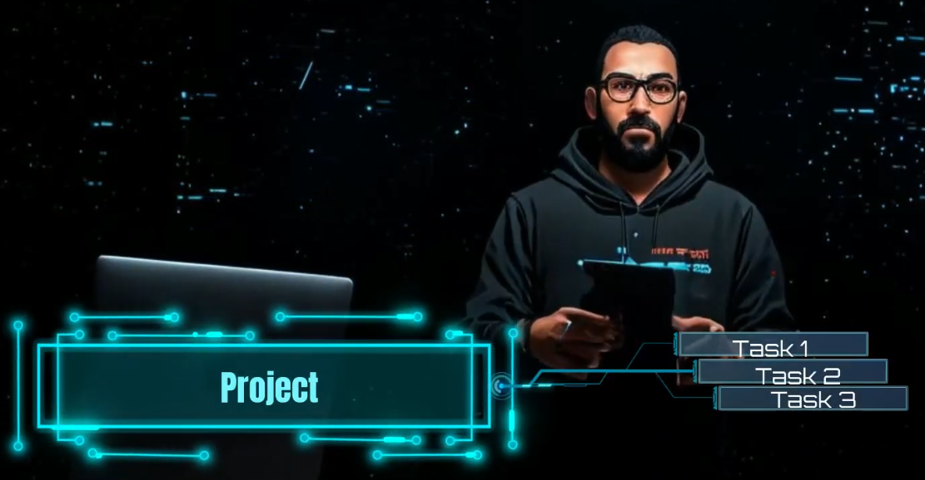

2-Scrum Process
Lecture 1- Intro to Agile, Scrum _ How to write_read User Story - start at 2:00

2.1-What is Scrum
Lecture 1- Intro to Agile, Scrum _ How to write_read User Story - start at 2:00
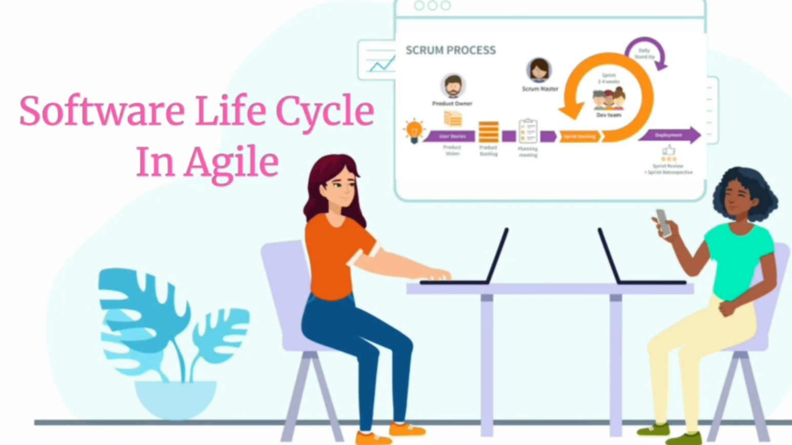
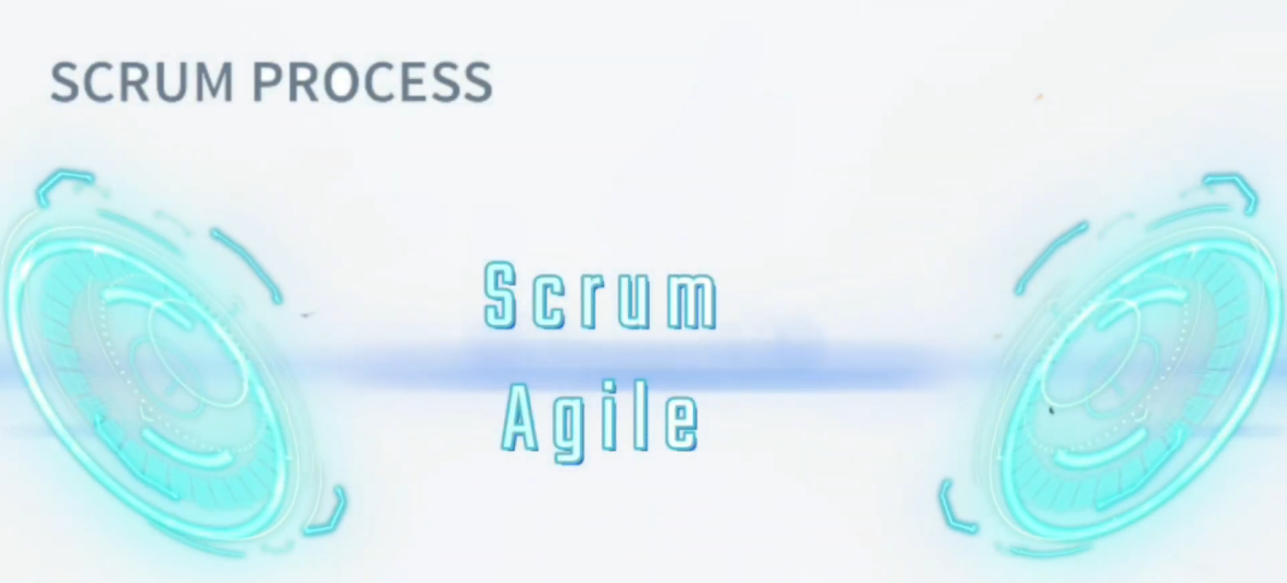
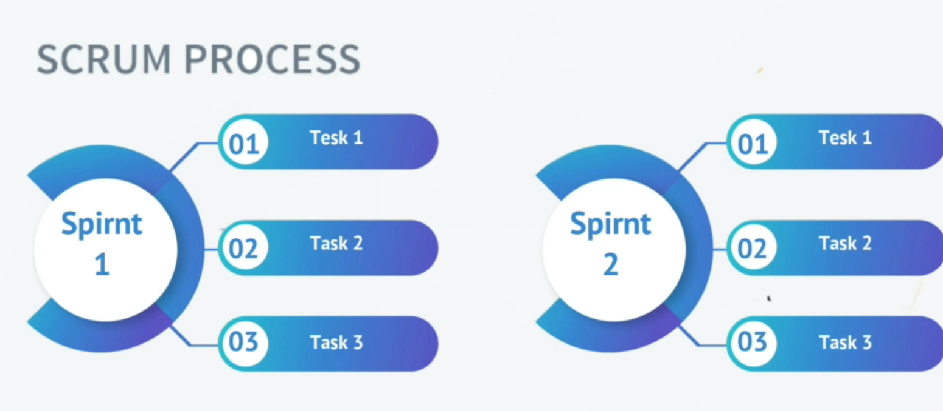

2.2-User Story, Product Owner and Product Backlog
Lecture 1- Intro to Agile, Scrum _ How to write_read User Story - start at 2:32
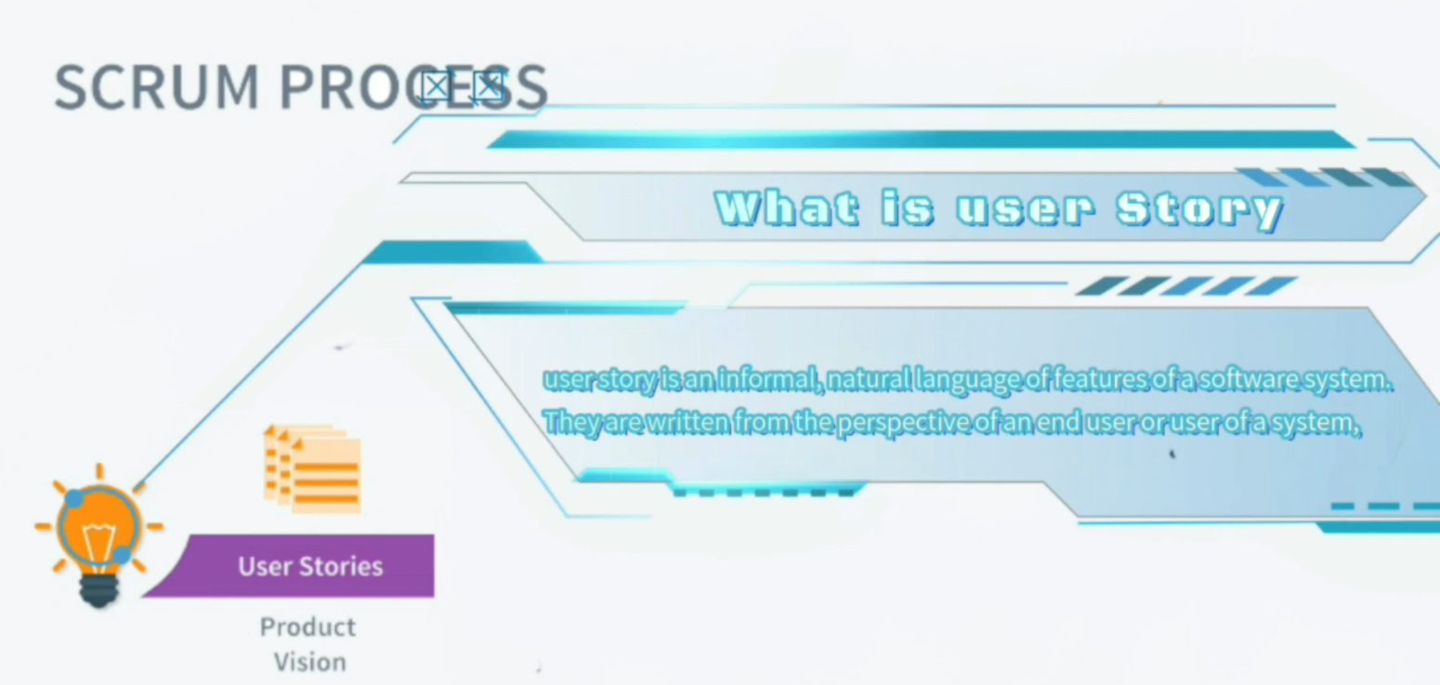
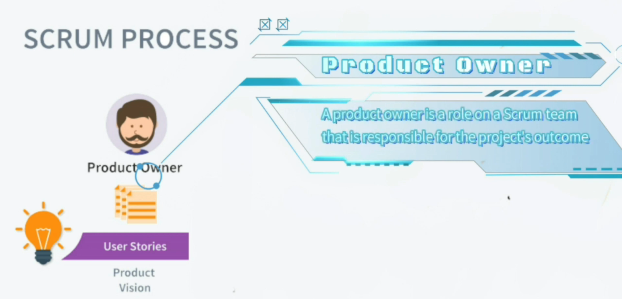
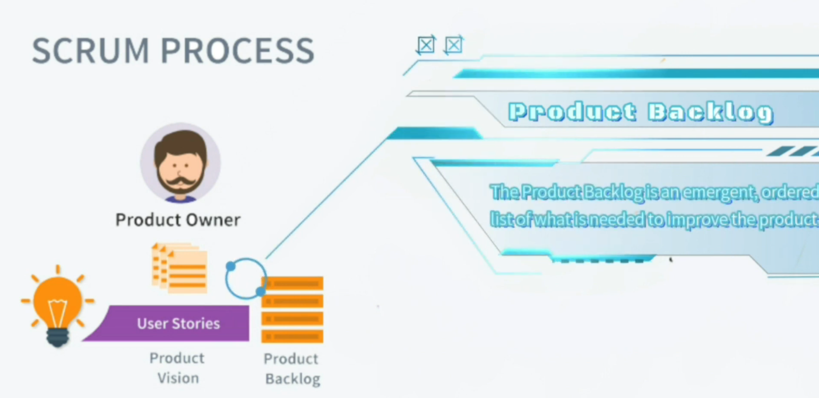

2.3-Planning Meeting, Sprint, Sprint Backlog and Scrum Master
Lecture 1- Intro to Agile, Scrum _ How to write_read User Story - start at 3:21
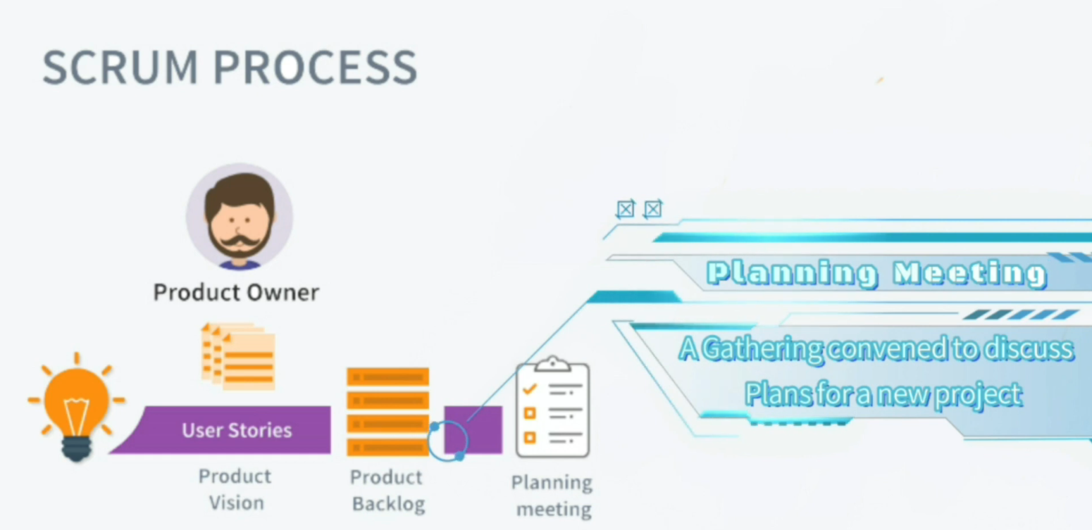
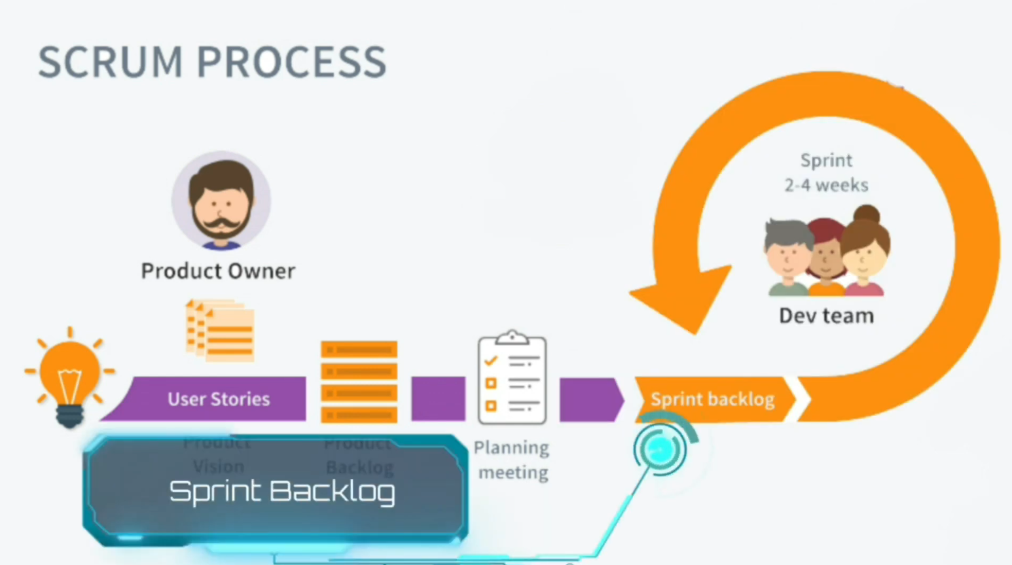
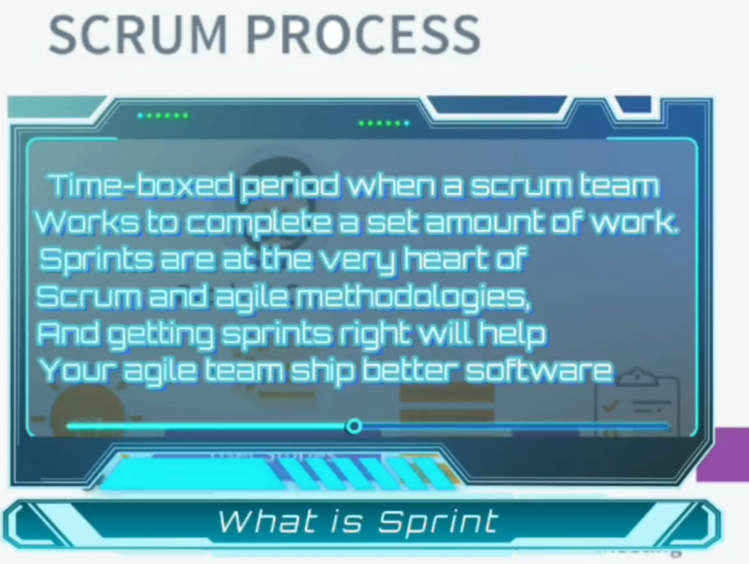
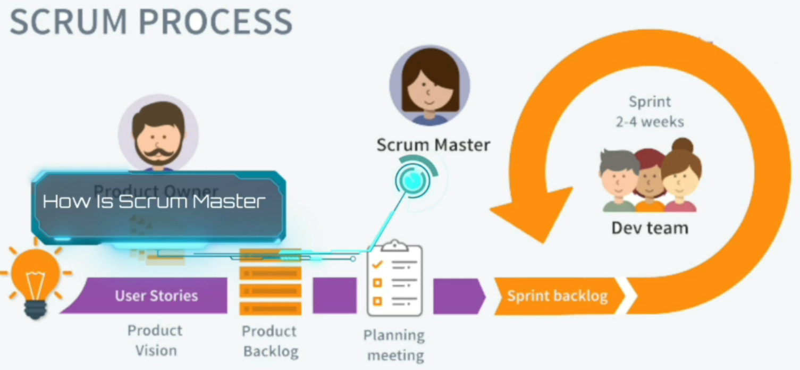

2.4-What is Daily standup meeting, Deployment
Lecture 1- Intro to Agile, Scrum _ How to write_read User Story - start at 4:36
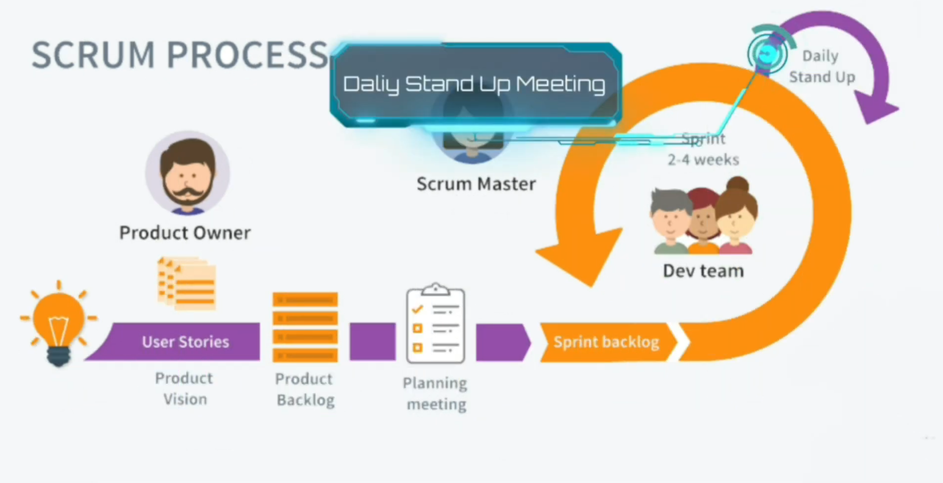
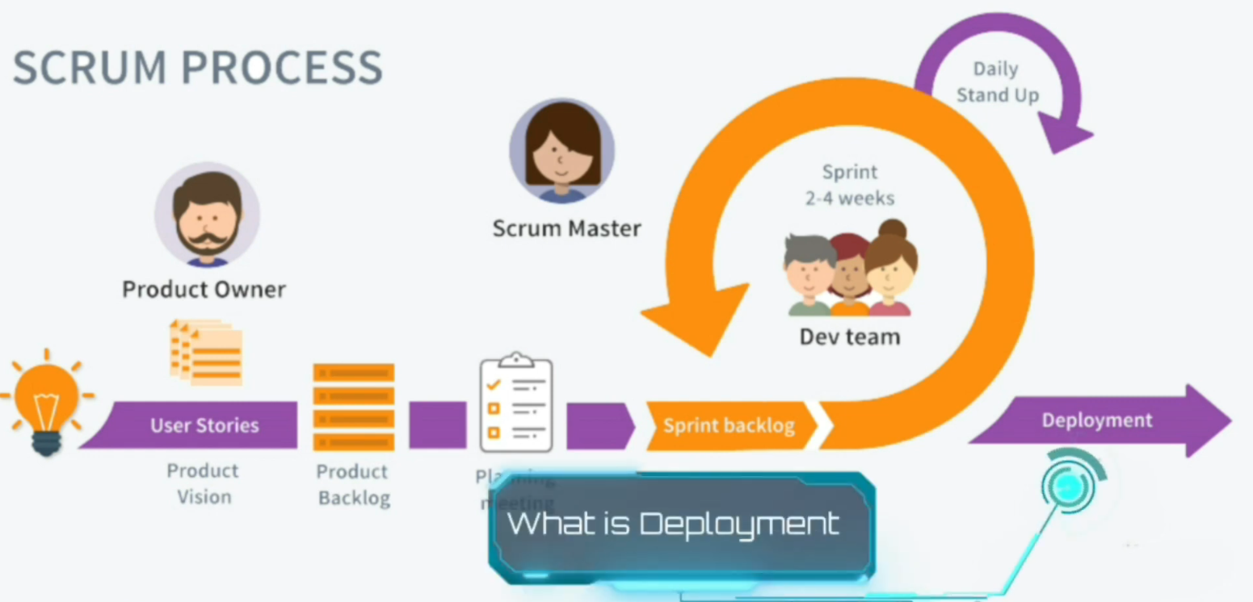

3-Sotware testing life cycle – User Story
Lecture 1- Intro to Agile, Scrum _ How to write_read User Story - start at 5:33

3.1-what is user story
Lecture 1- Intro to Agile, Scrum _ How to write_read User Story - start at 5:57
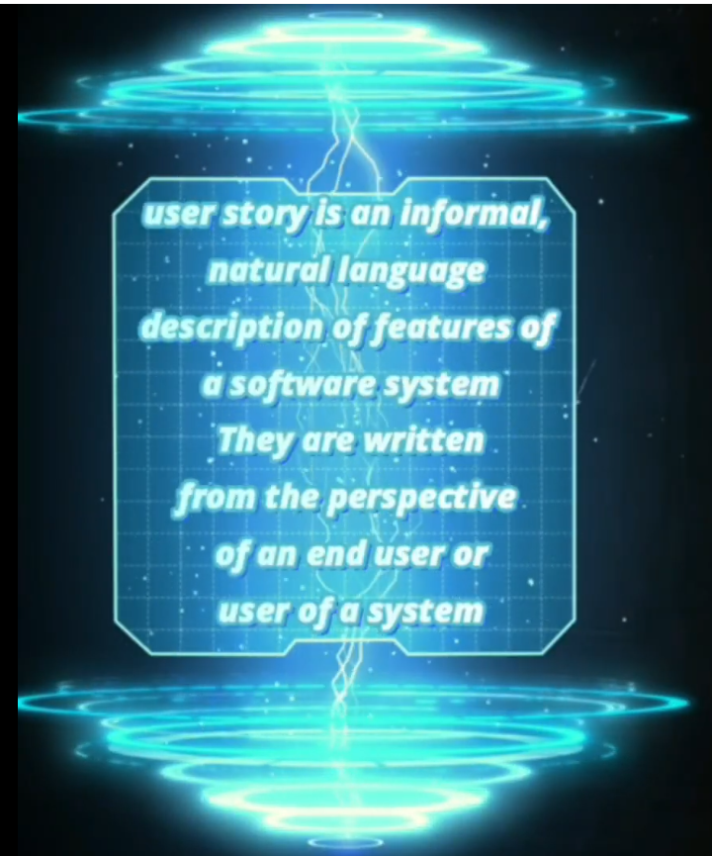
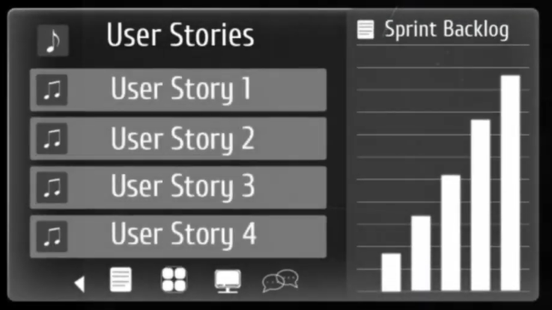

3.2-Read user story
Lecture 1- Intro to Agile, Scrum _ How to write_read User Story - start at 6:17
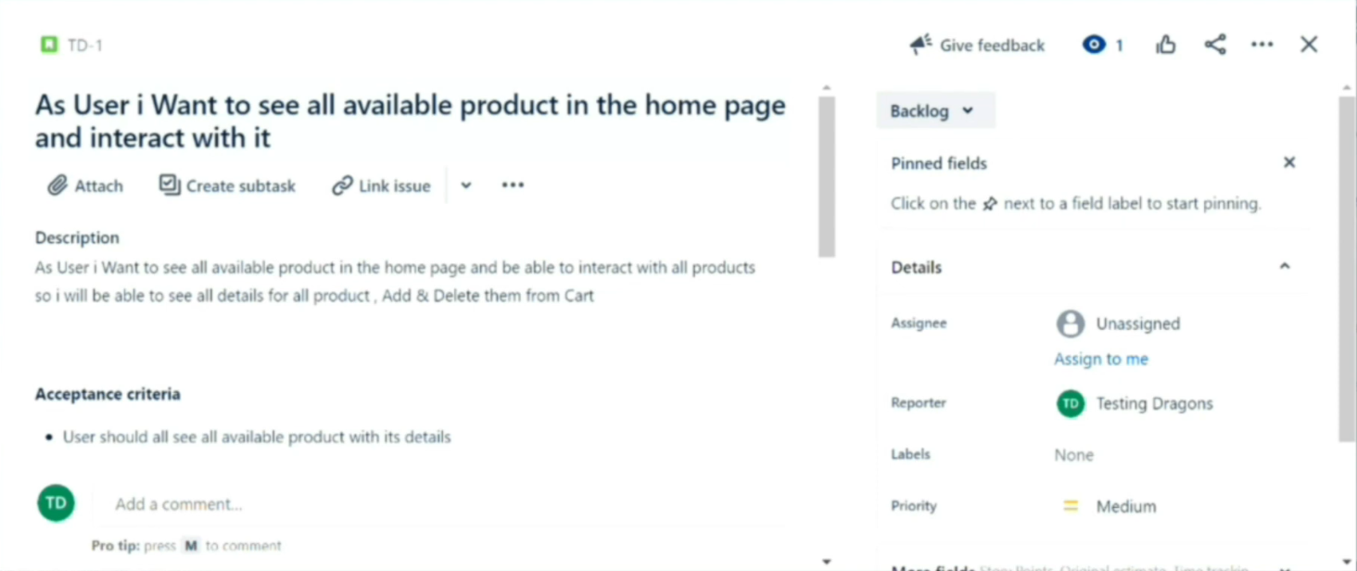
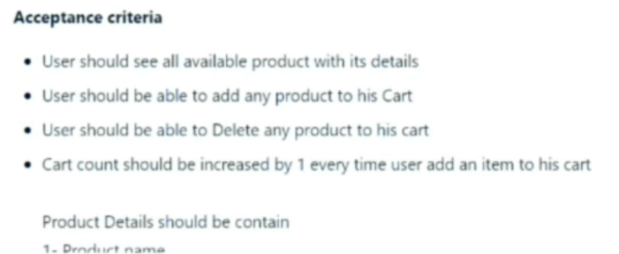
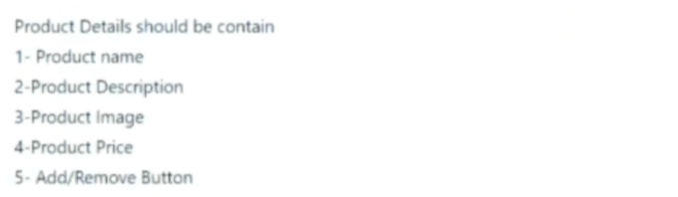
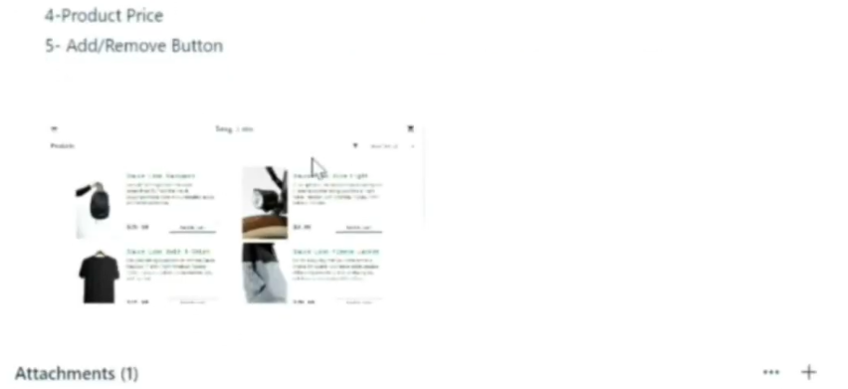
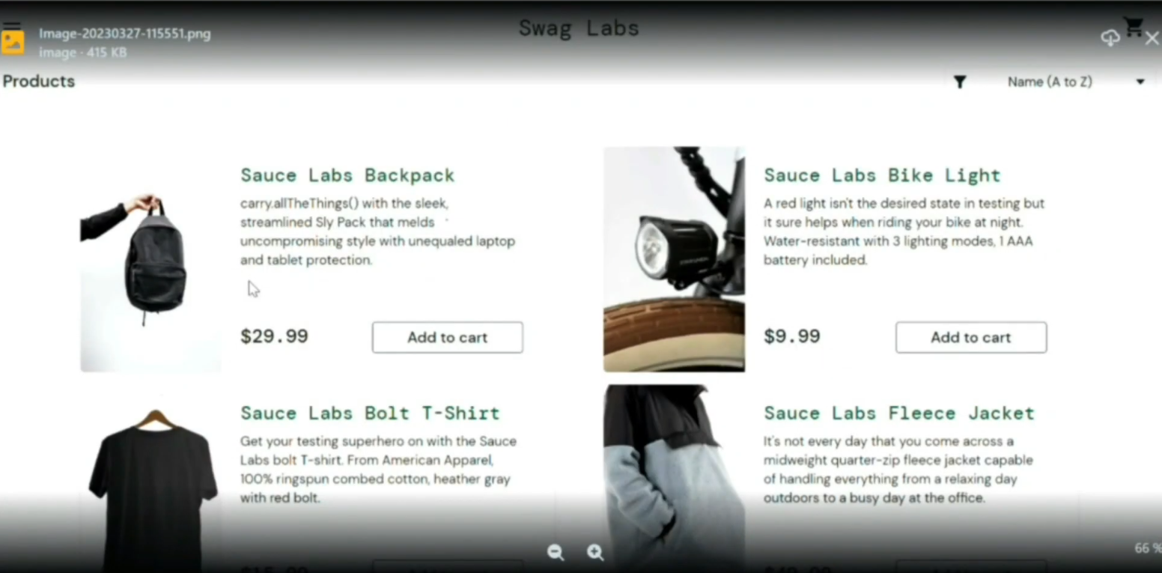

3.2-Analysis user story - Convert user story to Test Cases
Lecture 1- Intro to Agile, Scrum _ How to write_read User Story - start at 8:53
Edit Acceptance criteria
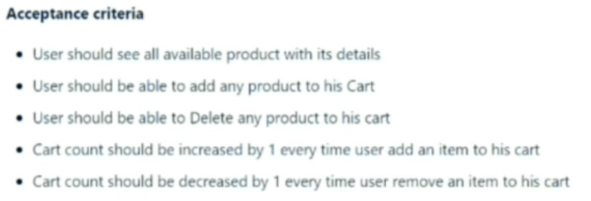

3.3-Write User Story
Lecture 1- Intro to Agile, Scrum _ How to write_read User Story - start at 11:41
